Retail sales Analysis Project Report
Executive Summary
This comprehensive analysis of retail sales reveals key insights that can drive strategic decisions for the retail company. The analysis identifies significant patterns across product clusters, product categories, and purchasing behaviors that can optimize marketing strategies, improve customer engagement, and increase revenue.

1. Project Overview
Business Context
A leading retail company sought to understand evolving sales patterns to enhance sales performance, customer satisfaction, and long-term loyalty. The analysis focuses on identifying key drivers of purchasing decisions across demographics, product categories, and sales channels.
Methodology
- Data Preparation & EDA: Python
- Data Analysis & SQL Queries: Microsoft SQL Server
- Visualization: Power BI Dashboard
- Database Management: MS SQL Server Management Studio 21
Dataset Specifications
- Records: 19 M records of sales transaction data
- Null records: 37 records of review rating were found and replaced by median or review rating
- Key Dimensions: store table, product table, sales table, date table.
- Time Frame: 2017 to 2019 data
- Data Points: 19 attributes including purchase amount, discount type

2. Data Preparation & Modeling
Data Cleaning Process
python
# Key steps performed in exploratory data analysis
- Data dimensions were inspected using the .shape attribute, and missing values were checked using .isnull().sum(). Memory usage for each dataset was computed to assess optimization opportunities.

- The 'date' column was parsed and converted to datetime format.
-Numeric columns (sales, revenue, stock, price) were converted to numeric types using pd.to_numeric().
- Blank strings in promotional columns were replaced with NaN.
- Missing numeric values in sales, revenue, and stock were logically filled with 0 to represent no activity, rather than missing data.
- All key identifiers (product_id, store_id) were validated for consistency across tables.
Feature engineering
New temporal and performance-related features were created:
- Year, Month, Month Name, and Week extracted from the 'date' column.
- Revenue per Unit = revenue / sales (avoiding division by zero).
- Stock Turnover = sales / stock (avoiding division by zero).
These features enhance analytical flexibility for trend and performance analyses.
Creating fact and dimension tables
Following best practices in data warehousing, the merged data was structured into a star schema:
- FactSales: Transactional data containing metrics like sales, revenue, stock, and promotions.
- DimProduct: Unique list of products with hierarchy details.
- DimStore: Unique list of stores with type, size, and city information.
- DimDate: System-generated date dimension to support time-based reporting.
Each table was exported to CSV for loading into SQL Server.
Data quality validation
Validation checks ensured:
- No missing foreign key references between tables.
- Correct data types for all columns.
- Logical imputation of missing values.
- Proper generation of derived metrics without division errors.

3. SQL Analysis & Key Findings
3.1 product performance analysis
To generate the highest 10 products in revenue and profit, We assumed that we have 30 % profit margin in our business and chose hirerachy3 in product dimension to balance the level of details of our required report in the below query.

Query: product performance
Sql
SELECT top 10
dp.hierarchy3_id,
SUM(fs.revenue) AS total_revenue,
SUM(fs.revenue * 0.30) AS estimated_profit
FROM fact_sales fs
JOIN dim_product dp ON fs.product_id = dp.product_id
GROUP BY dp.hierarchy3_id

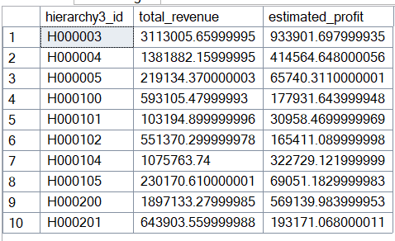
Finding:
3.2 store performance
SELECT top 5
fs.store_id,
ds.storetype_id,
SUM(fs.sales) AS total_units_sold,
SUM(fs.revenue) AS total_revenue
FROM fact_sales fs
JOIN dim_store ds ON fs.store_id = ds.store_id
GROUP BY fs.store_id, ds.storetype_id
ORDER BY total_revenue DESC;

Top 5 stores
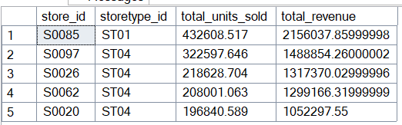
Bottom 5 stores
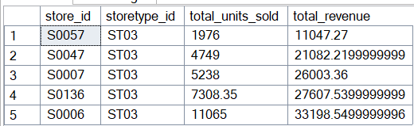

Store performance showed the best and worst performing stores in terms of sales to investigate the reason.
3.3 sales and stock Performance relation
In this query I decided to see the product cluster performance with stock and stock turnover to get more useful information
SELECT
dp.cluster_id as product_cluster,
AVG(fs.stock) AS avg_stock,
AVG(fs.sales) AS avg_sales,
AVG(fs.stock_turnover) AS turnover_ratio
FROM fact_sales fs
join dim_product dp on fs.product_id = dp.product_id
GROUP BY dp.cluster_id
ORDER BY turnover_ratio DESC;

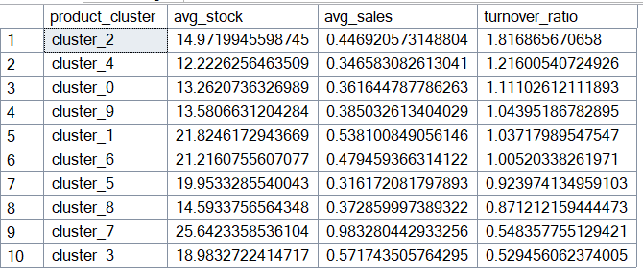
3.4 revenue and store size relation
I chose to get the top 10 stores that generate revenue per sqm
SELECT TOP 10
ds.store_id,
ds.store_size,
SUM(fs.revenue) / ds.store_size AS revenue_per_sqm
FROM fact_sales fs
JOIN dim_store ds ON fs.store_id = ds.store_id
GROUP BY ds.store_id, ds.store_size
ORDER BY revenue_per_sqm DESC;
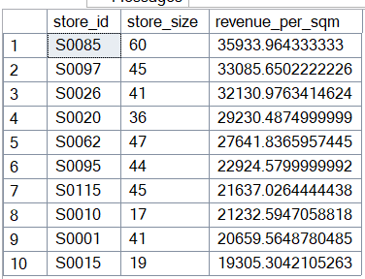

3.5 promotion Effectiveness across cities
SELECT
ds.city_id,
fs.promo_type_1,
fs.promo_type_2,
AVG(fs.sales) AS avg_sales
FROM fact_sales fs
JOIN dim_store ds ON fs.store_id = ds.store_id
WHERE fs.promo_type_1 IS NOT NULL OR fs.promo_type_2 IS NOT NULL
GROUP BY ds.city_id, fs.promo_type_1, promo_type_2
ORDER BY ds.city_id, avg_sales DESC;
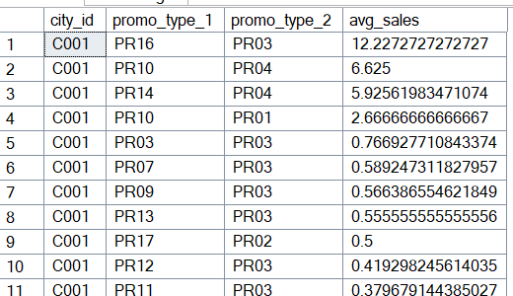

4. Advanced SQL Analytics
4.1 Category Performance Ranking
Implemented window functions to identify top-performing products within each category, enabling targeted inventory management.
4.2 Customer Lifetime Value Indicators
Analyzed previous purchase patterns to predict future customer value and identify at-risk segments.
4.3 Seasonal Purchase Patterns
Identified seasonal trends affecting purchase amounts and product preferences.

5. Technical Implementation
Database Architecture
- Platform: Microsoft SQL Server 2022 Express
- Connection: ODBC Driver 17 with SQLAlchemy
- Database: retail_sales
- Primary Table: sales analysis across multiple stores and cities
SQL Server Configuration
- Instance: DESKTOP-ECBFCCK\SQLEXPRESS
- Authentication: Windows & SQL Server Authentication
- Port Configuration: Dynamic port allocation with SQL Browser service
Data Pipeline
text
python (EDA) → SQL Server (Analysis) → Power BI (Visualization)

6. Power BI Dashboard Development
Dashboard Components
Created multi-page dashboard that contains: Home, product insights, store insights, promotions, inventory, profitability and general trends.
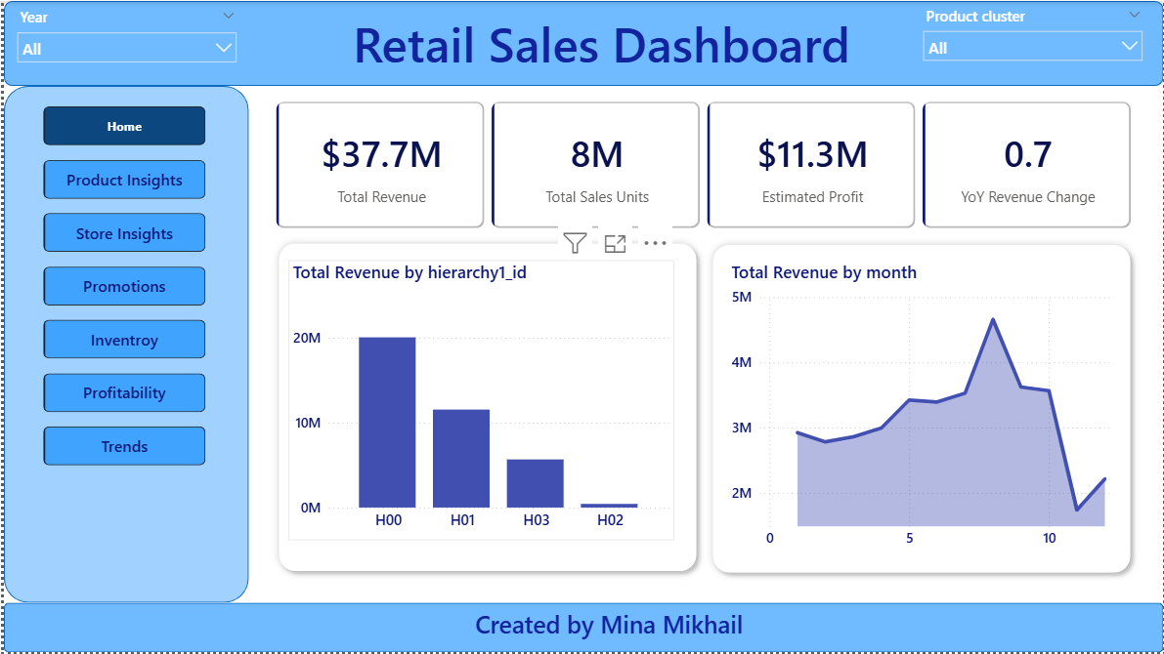
Figure 1Home page
Interactive Features
- Dynamic filtering by demographic segments
- Time-series analysis capabilities
- Drill-through product performance
- Comparative analysis across stores.

7. Key Business Insights
7.1 sales patterns
- Highest revenue may to august represent the highest generating revenue period.
- Highest hierarchy hierarchy H00 and H01 generate 84% of total profit.
- Store type store type ST04 and ST01 generate 83% of revenue.
- Store size sensitivity store type ST04 and ST01 are the highest stores generating revenue per store size.
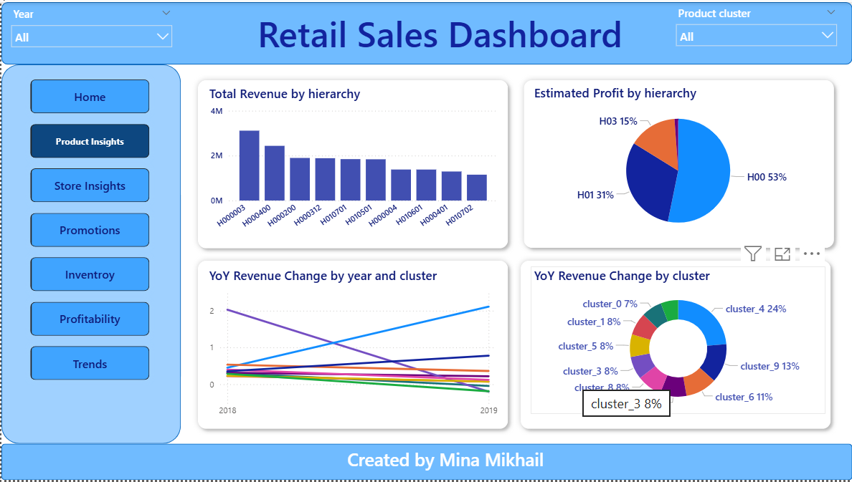
Figure 2 Product insights
7.2 Promotions behavior
- Promotion type 1 PR03 and PR07 represent 71% of totals sales.
- Promotion type 2 PR03 represents 99.6% of totals sales.
- Promotion type 1 achieved 471K of sales.
- PR03 represents 49% of promo type 1 and city C014 and C022 represent 24% of PR03 in promo type1.
- Promo type 2 achieved 19M of sales.
- PR03 represents 99.7% of promo type 2 and city C014 and C022 represent 35% of PR03 in promo type2.
- Conclusion PR03 was greatly successful within promo type 1 and promo type 2 in both cities C014 and C022, therefore our promo campaigns should use those promos for these cities to achieve the highest results.
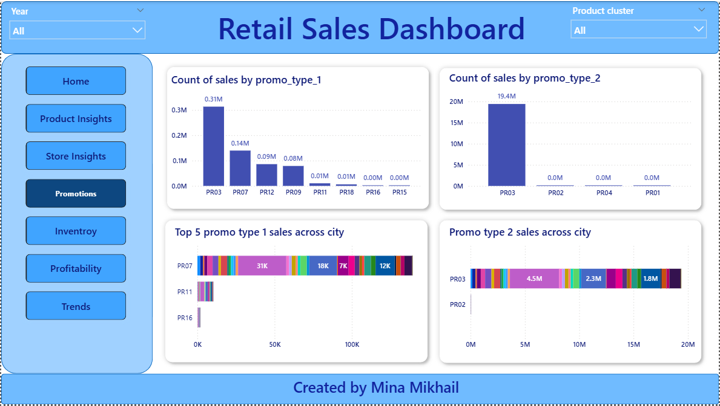
Figure 3 Promotion insights
7.3 Store behavior
- We have the tope 5 stores generating revenue and lowest 5 stores generating revenue in the below page.
- We need recognition for the highest performing stores and training plan for the lowest performance stores.
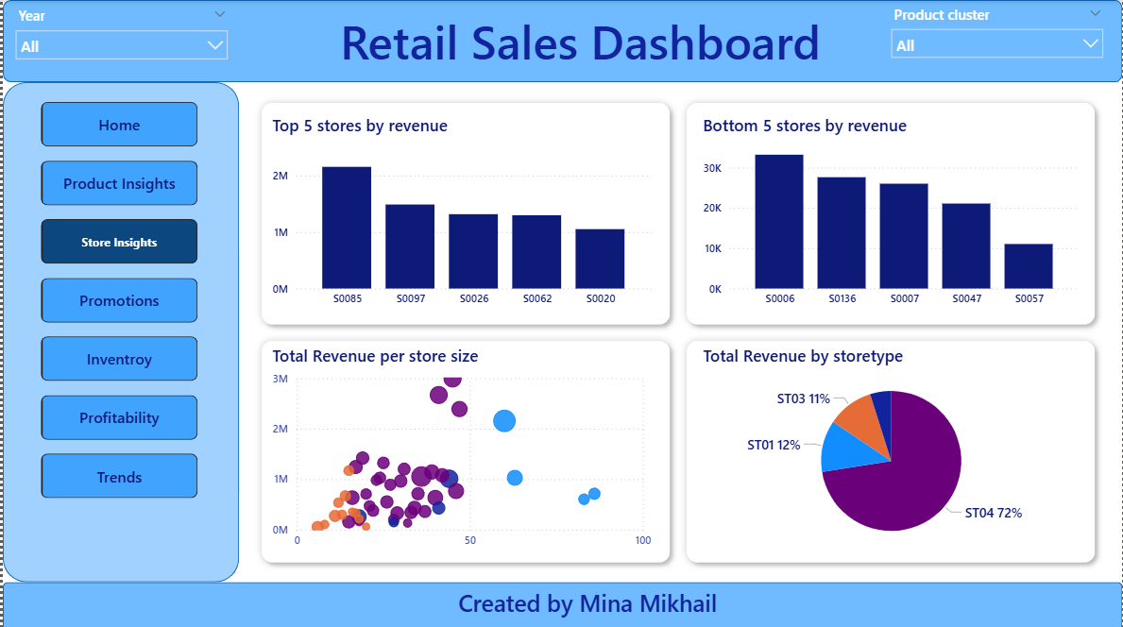
Figure 4 Store insights
7.4 inventory
- Hierarchy H02 represents 40% of the top sales to stock ratio.
- Product clusters 3, 7 and 9 represent 45% of stock turnover.
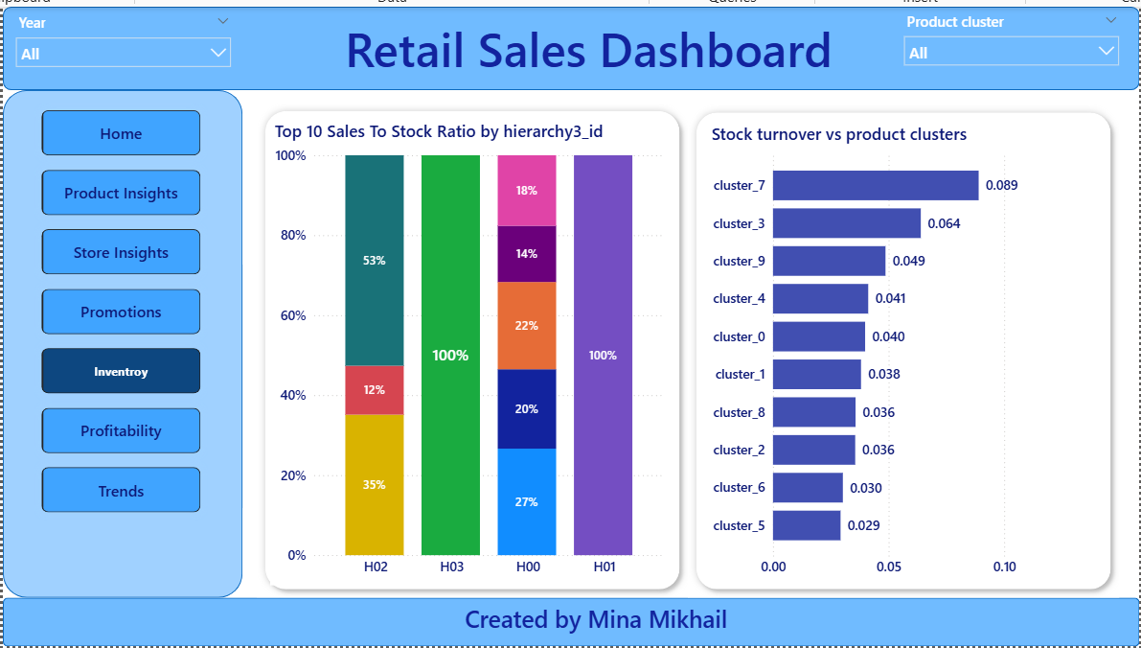
Figure 5 Inventory insights
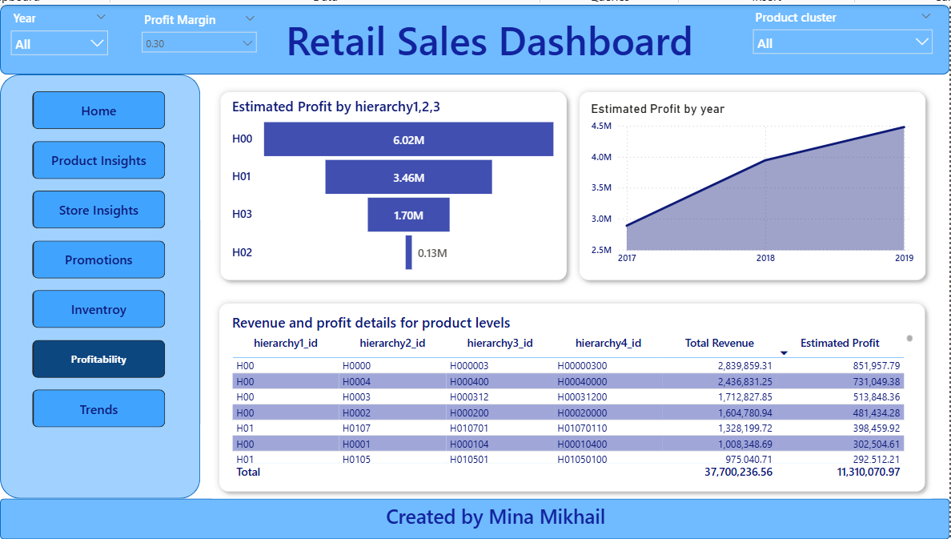
Figure 6 Profitability insights
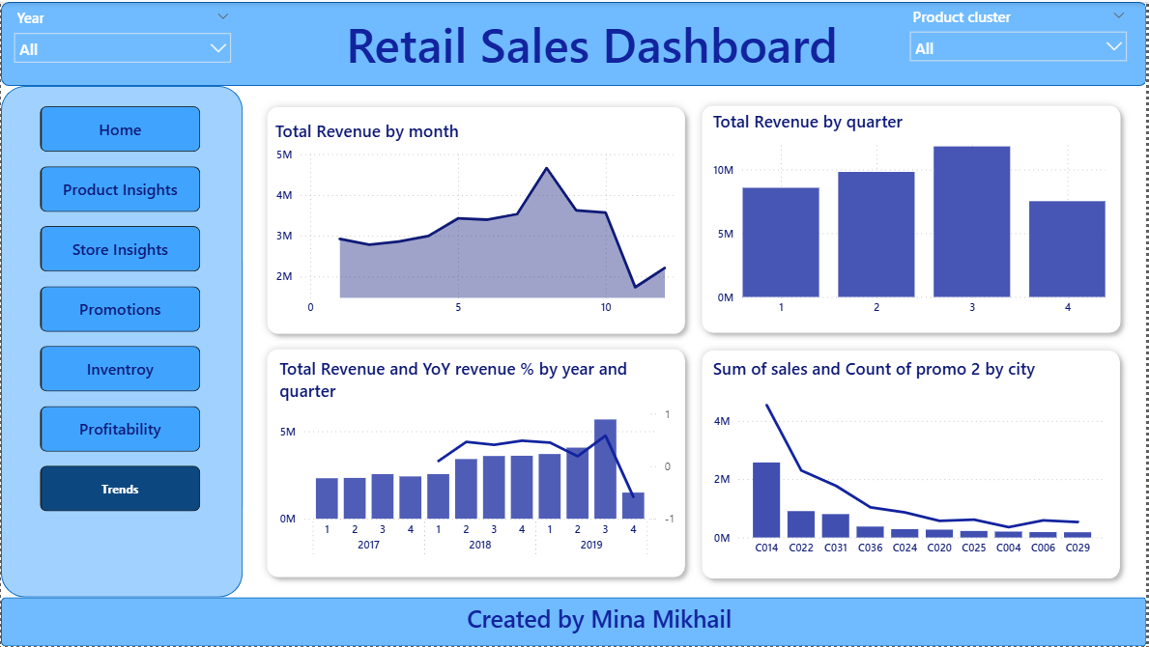
Figure 7 General trends
8. Strategic Recommendations
Immediate Actions (0-3 Months)
- Enhance Loyalty Program: Target returning customers with personalized offers
- Optimize Discount Strategy: Focus on high-margin products with strategic discounts
Medium-term Initiatives (3-6 Months)
- Personalized Marketing: Implement promo-specific campaigns
- Inventory Optimization: Align stock levels with category performance insights
- Customer Journey Mapping: Improve touchpoints based on frequency patterns
Long-term Strategy (6-12 Months)
- Predictive Analytics: Develop churn prediction models
- Customer Lifetime Value Optimization: Focus on high-value segment retention
- Product Development: Use rating and review insights for new product planning

9. Technical Achievements
SQL Optimization
- Implemented efficient CTEs and window functions
- Optimized query performance for large datasets
- Developed reusable analytical queries
Data Integration
- Successful connection between Python, SQL Server, and Power BI
- Robust error handling and connection management
- Scalable architecture for future data growth
Visualization Excellence
- Interactive dashboards with drill-down capabilities
- Clear metric visualization for executive reporting
- User-friendly interface for business users

10. Conclusion
This comprehensive analysis provides actionable insights that can significantly impact the company's bottom line. By leveraging these data-driven findings, the organization can:
- Increase customer retention through targeted loyalty programs
- Optimize marketing spend with segment-specific strategies
- Enhance product offerings based on performance analytics
- Improve operational efficiency through pattern recognition
The implemented technical solution provides a scalable foundation for ongoing customer behavior analysis and business intelligence.

